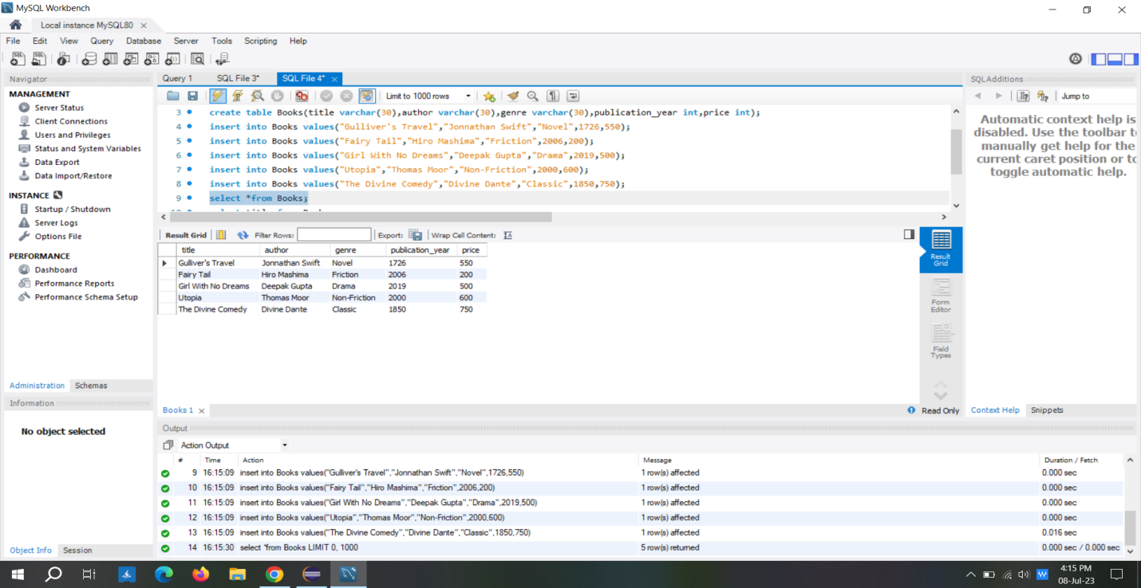

Retrieve all the books from the database

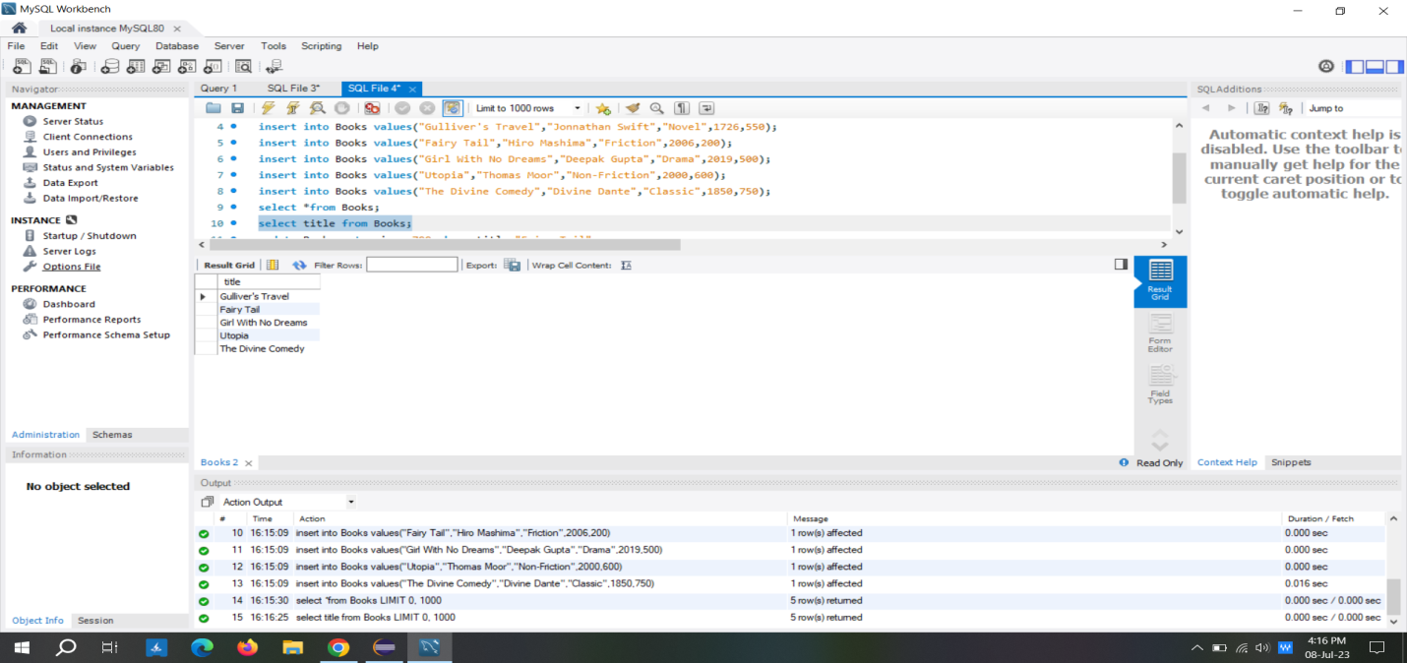

Retrieve the details of a book based on its title

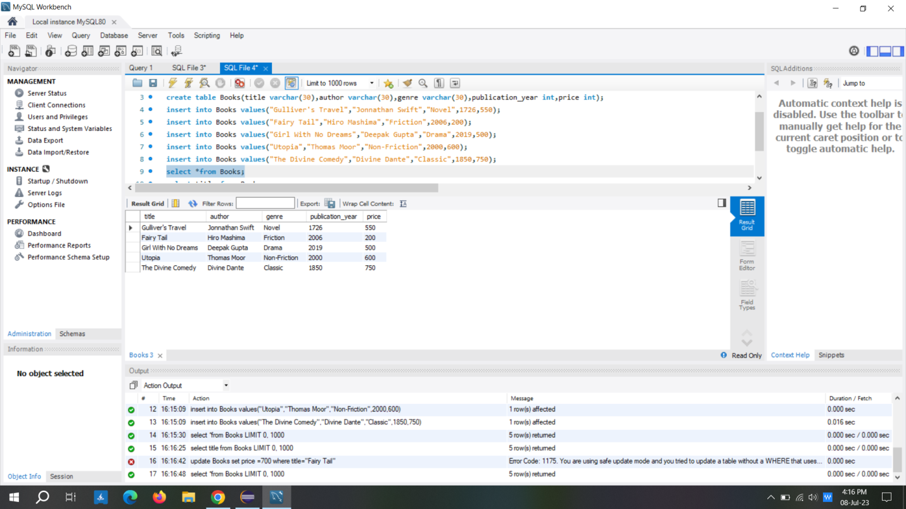

Update the price of a book

Delete a book from the database based on its title.

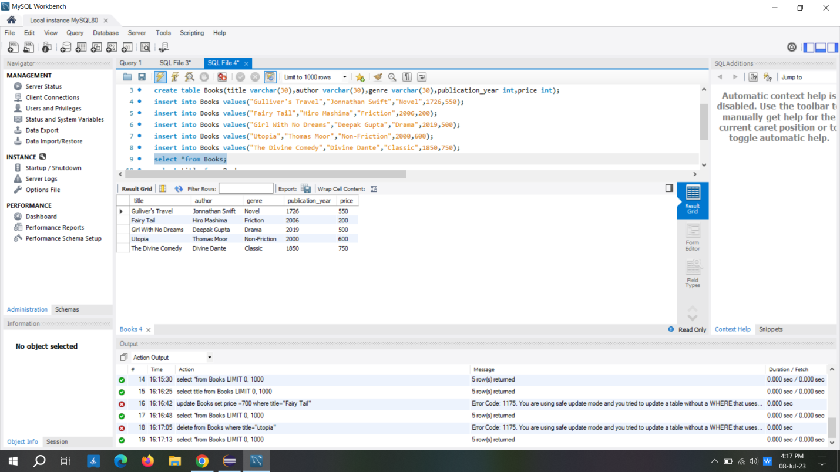

Delete a book from the database based on its title.